Sreeti Ravi

I590 Python

Assignment 1

Decision Statements

1. 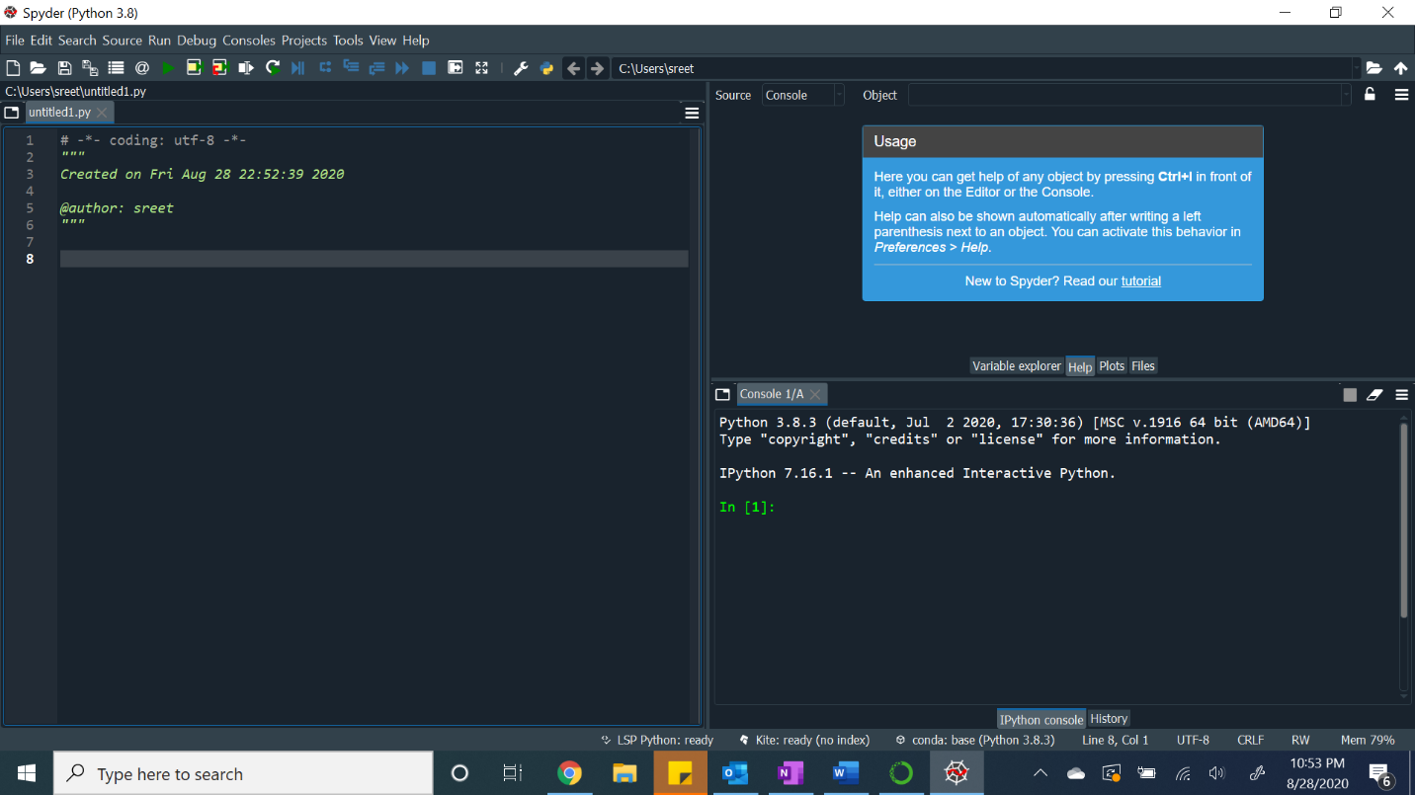

2.1.

def circleArea(r):

print(3.14 \* (r \*\* 2))

2.2

def kilometersToMiles(km):

print(km \* 0.62)

2.3

def squareArea(side):

print(side \*\* 2)

3.1

def firstFiveSquares():

for i in range (1, 6):

print(i\*\*2)

3.2

def firstTenReverse():

for i in range (10, 0, -1):

print (i\*2)